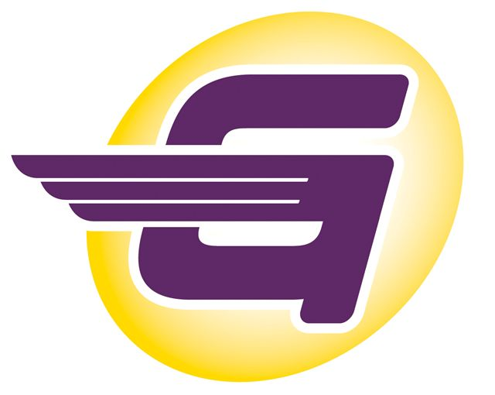
2024 Track Season Summary
The 2024 track season started with conditioning in February and the first practice and the annual registration meeting the first week in March. The Gliders competed in the annual Smile Mile race with 8 athletes in the top ten including a second and third place. The club then competed in local meets in April and May. Several high school Gliders competed and qualified for the regional and state high school championships in Jacksonville. Also in May, the Gliders were honored to be bused to Gainesville by an Olympic vendor to be in a photo/video session with Olympian hurdler Grant Holloway. Amazingly, the video was aired during the Olympics to the delight of our athletes, alumni and supporters!

In June, the Gliders competed in the district and regional AAU and USATF meets qualifying 10 athletes to the AAU Nationals in Greensboro and the USATF Nationals on the campus of Texas A & M University while two Gliders medaled at the USATF Youth Nationals in New York City. In July
at the 2024 USA National Championships in Eugene, a former Glider again qualified in the triple jump and competed in the Olympics in Paris!
The Gliders had a fund-raising program and with donations from the parents, we were able to get two new tents for team competition. We
had the season-ending party at Congo Golf and continued our community service program by donating to an organization that helps the homeless. Many thanks to the Track Shack, Publix, Help Kids play Sports, Lake Brantley and Edgewater High Schools, and all of our sponsors, alumni
and supporters who helped make this season possible.
Central Florida Gliders Track Club
PO Box 161965 Altamonte Springs 32716
Contact: info@cfgliders.com

